# JS Applications Exam Preparation - SoftWiki

You are assigned to implement a **Web application** (SPA) using JavaScript. The application should dynamically display content, based on user interaction and support user profiles and CRUD operations, using a REST service.

## Overview

**Implement** a front-end app (SPA) for viewing and managing **wiki** **articles**. The application allows visitors to **browse** and **read** articles on various topics in **four** programming-related **categories**. Users may **register** with an **email** and **password**, which allows them to **create** their own articles. Article authors can also **edit** or **delete** their own publications at any time.

## Technical Details

You are provided with the following resources:

* **Project scaffold**: A **package.json** file, containing a list of common dependencies. You may change the included libraries to your preference. The sections **devDependencies** and **scripts** of the file are used by the automated testing suite, altering them may result in incorrect test operation.

To **initialize** the project, execute the command npm install via the command-line terminal.

* **HTML** **and CSS files**: All views (pages) of the application, including **sample** user-generated **content**, are included in the file **index.html**, which links to CSS and other static files. **Each view is in a separate section** of the file, which can be identified by a **unique class name or id** attribute. Your application may use any preferred method (such as a **templating library** or manual visibility settings) to display only the selected view and to **navigate** between views upon user interaction.
* **Local** **REST service**: A special server, which contains **sample data** and supports **user registration** and **CRUD operations** via REST requests is included with the project. Each section of this document (where applicable) includes details about the necessary **REST endpoints**, to which **requests** must be sent, and the **shape** of the expected **request body**.

For **more information** on how to use the included server, see **Appendix A: Using the Local REST Service** at the end of this document.

* **Automated tests**: A complete test suite is included, which can be used to test the correctness of your solution. **Your work will be assessed, based on these tests.**

For **more information** on how to run the tests, see **Appendix B: Running the Test Suite** at the end of this document

**Do not use CDN** for loading the dependencies because it can **affect the tests in a negative** **way**!

**Note:** When creating HTML Elements and displaying them on the page, **adhere as close as possible to the provided HTML** samples. Changing the structure of the document may **prevent the tests** from running correctly, which will **adversely affect your assessment grade**. You may **add attributes** (such as **class** and **dataset**) to any HTML Element, as well as **change "href"** attributes on links and add/change the **method** and **action** attributes of HTML Forms, to facilitate the correct operation of a routing library or another method of abstraction. You may also add hidden elements to help you implement certain parts of the application requirements.

## Application Requirements

### Navigation Bar (5 pts)

Navigation links should correctly change the current page (view). **SoftWiki** link should redirect to the **Home** page. **Guests** (un-authenticated visitors) can see the links to the **All Articles (Catalogue)** page, **Search** page as well as the links to the **Login** and **Register** pages. The logged-in user navbar should contain the links to **All Articles** **(Catalogue)** page, **Search** page, the **Create** page and a link for e **Logout** action.

**Guest** navigation example: 

**User** navigation example: 

### Login User (5 pts)

The **included REST service** comes with the following **premade** user accounts, which you may use for development:

{ "email": "peter@abv.bg", "password": "123456" }

{ "email": "john@abv.bg", "password": "123456" }

The **Login** page contains a form for existing user authentication. By providing an **email** and **password,** the app should login a user in the system if there are no empty fields.

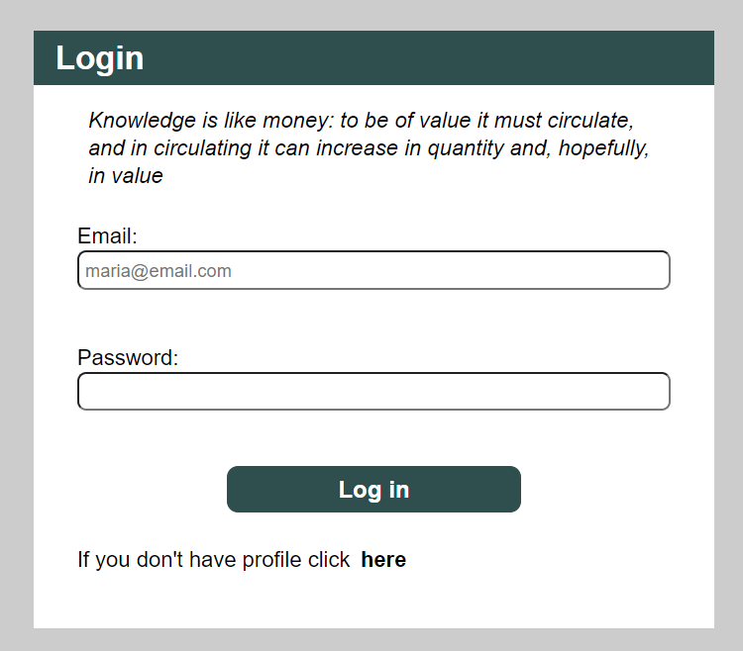

Send the following **request** to perform login:

Method: POST

URL: /users/login

Required **headers** are described in the documentation. The service expects a body with the following shape:

{

email,

password

}

Upon success, the **REST service** will return information about the existing user along with a property **accessToken**, which contains the **session token** for the user **–** you need to store this information using **sessionStorage** or **localStorage,** in order to be able to perform authenticated requests.

If the login was successful, **redirect** the user to the **Home** page. If there is an error, display an appropriate error message, using a system dialog (window.alert).

### Register User (10 pts)

The **Register** page contains a form for new user registration. By providing an **email** and **password,** the app should register a new user in the system if there are no empty fields.

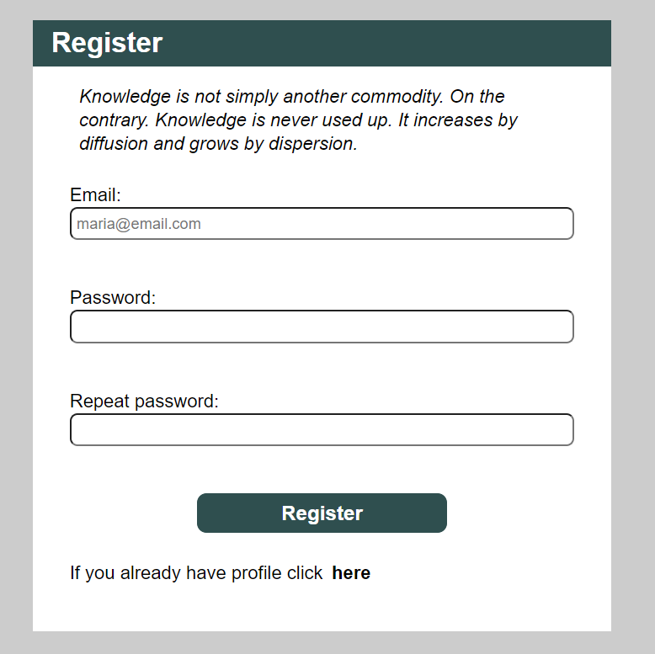

Send the following **request** to perform registration:

Method: POST

URL: /users/register

Required **headers** are described in the documentation. The service expects a body with the following shape:

{

email,

password

}

Upon success, the **REST service** will return the newly created object with an automatically generated **_id** and a property **accessToken**, which contains the **session token** for the user **–** you need to store this information using **sessionStorage** or **localStorage,** in order to be able to perform authenticated requests.

If the registration was successful, **redirect** the user to the **Home** page. If there is an error, or the **validations** don’t pass, display an appropriate error message, using a system dialog (window.alert).

### Logout (5 pts)

The logout action is available to logged-in users. Send the following **request** to perform logout:

Method: GET

URL: /users/logout

Required **headers** are described in the documentation. Upon success, the **REST service** will return an **empty response**. Clear any session information you’ve stored in browser storage.

If the logout was successful, **redirect** the user to the **Home** page.

### All Articles Page (Catalogue) (10 pts)

This page displays a list of all articles in the system, with their title and category. Clicking on any of the cards leads to the details page for the selected article.

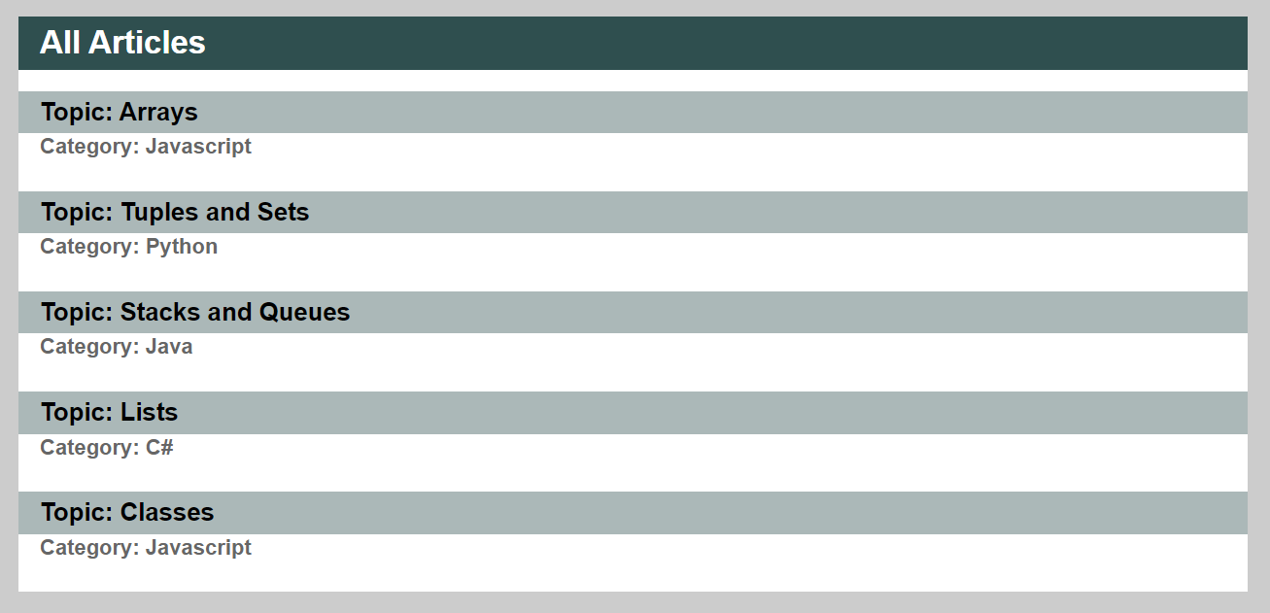

If there are noarticles, the following view should be displayed:



Send the following **request** to read the list of articles:

Method: GET

URL: /data/wiki?sortBy=_createdOn%20desc

Required **headers** are described in the documentation. The service will return an array of articles.

### Home Page (Recent Articles) (15 pts)

All users should be welcomed by the Homepage, where they should be able to see the most recent article for each category. The categories are **JavaScript**, **C#**, **Java**, and **Python**. Clicking on the Details links leads to the details page for the selected article.

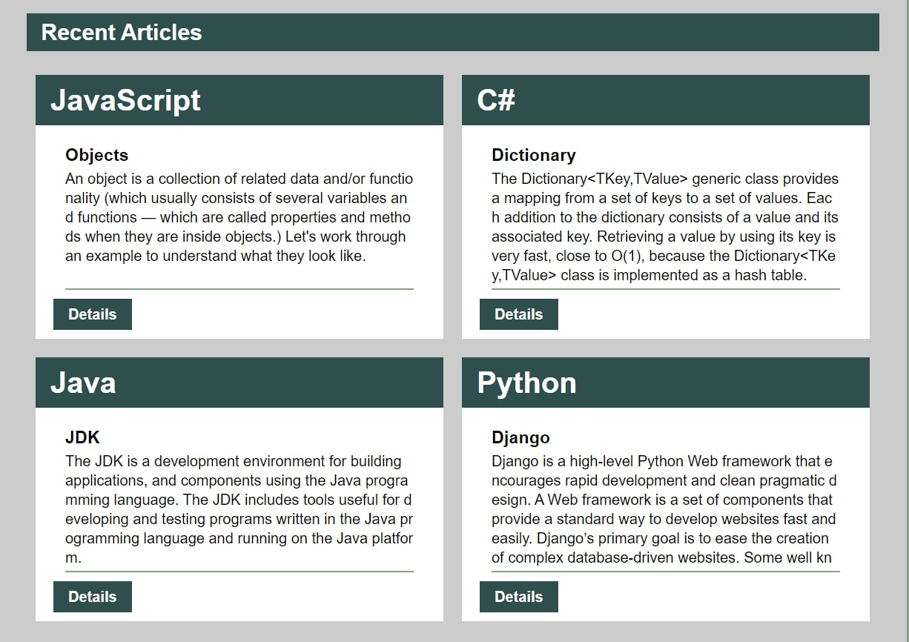

If any of the categories has no articles, display the text **"No articles yet"** in its section instead.

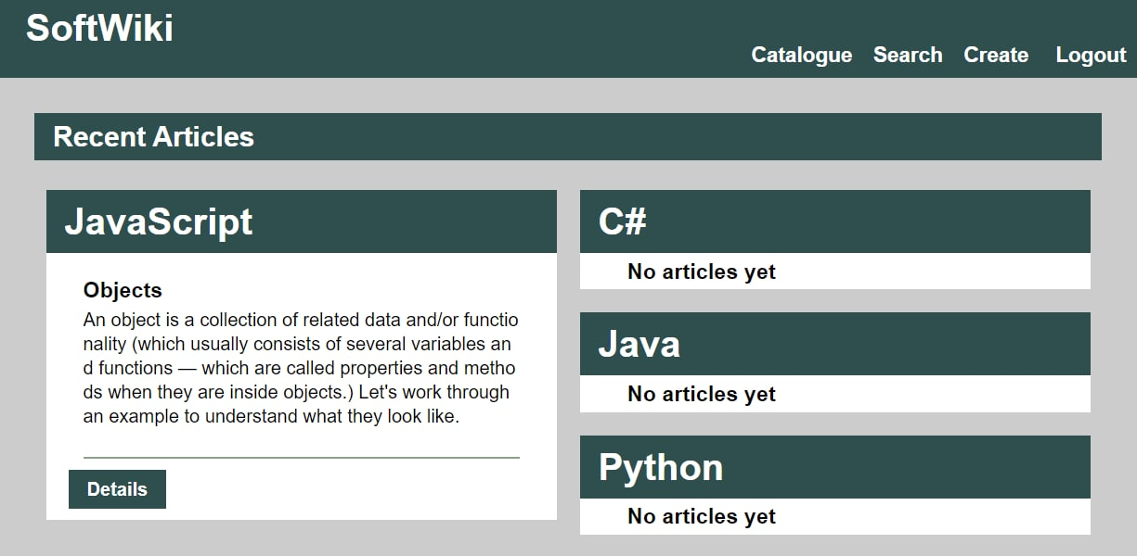

Send the following **request** to read the most recent articles:

Method: GET

URL: /data/wiki?sortBy=_createdOn%20desc&distinct=category

Required **headers** are described in the documentation. The service will return an array of articles.

### Create Article (15 pts)

The Create page is available to logged-in users. It contains a form for creating new articles. Check if all the fields are filled before you send the request. The category must be one of **"JavaScript"**, **"C#"**, **"Java"**, or **"Python"**.

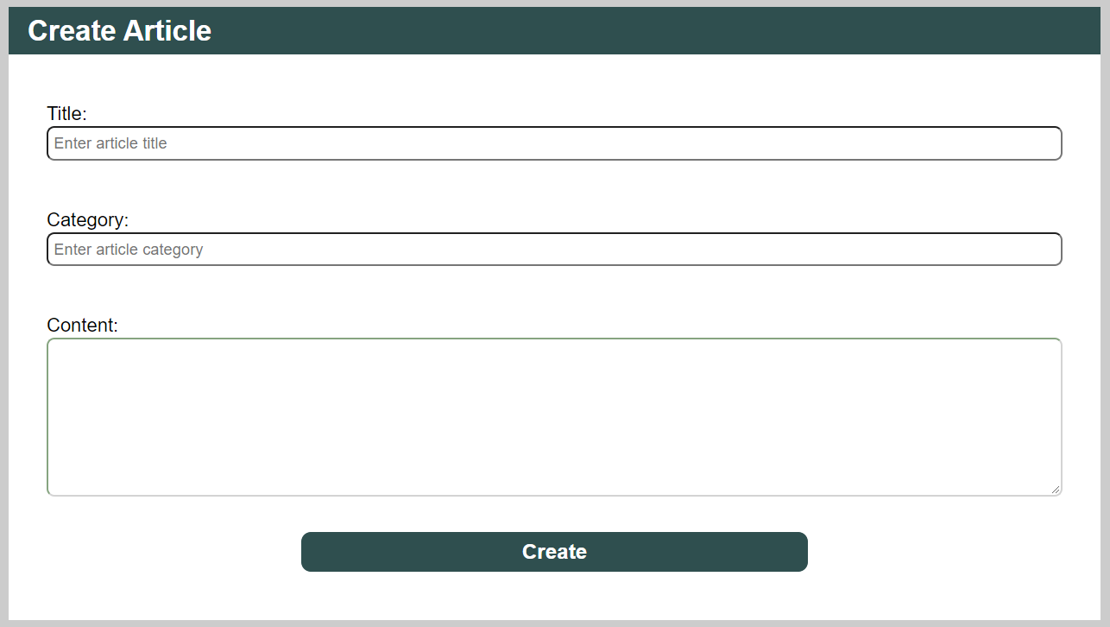

To create an article, send the following **request**:

Method: POST

URL: /data/wiki

Required **headers** are described in the documentation. The service expects a body with the following shape:

{

title,

category,

content

}

Required **headers** are described in the documentation. The service will return the newly created record. Upon success, **redirect** the user to the **Home** page.

### Details (10 pts)

All users should be able to **view details** aboutarticles. Clicking the **Details** link in of an **article** should **display** the **Details** page. If the currently logged-in user is the creator of the article, the **Edit** and **Delete** buttonsshould be displayed, otherwise only the **Back** button should be available, which redirects to the **Home** Page.

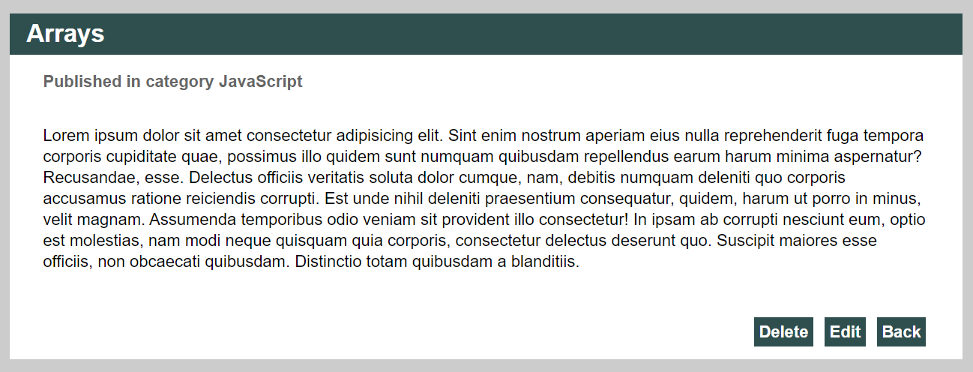

Send the following **request** to read a single article:

Method: GET

URL: /data/wiki/*:id*

Where ***:id*** is the **id** of the desired article. Required **headers** are described in the documentation. The service will return a single object.

### Edit Article (15 pts)

The Edit page is available to logged-in users and it allows author to **edit** their **own** articles. Clicking the **Edit** link of a particular article on the **Details** page should display the **Edit** page. It contains a form with input fields for all relevant properties. Check if all the fields are filled before you send the request. The category must be on of **"JavaScript"**, **"C#"**, **"Java"**, or **"Python"**.

The fields must be filled in at initial page loading.

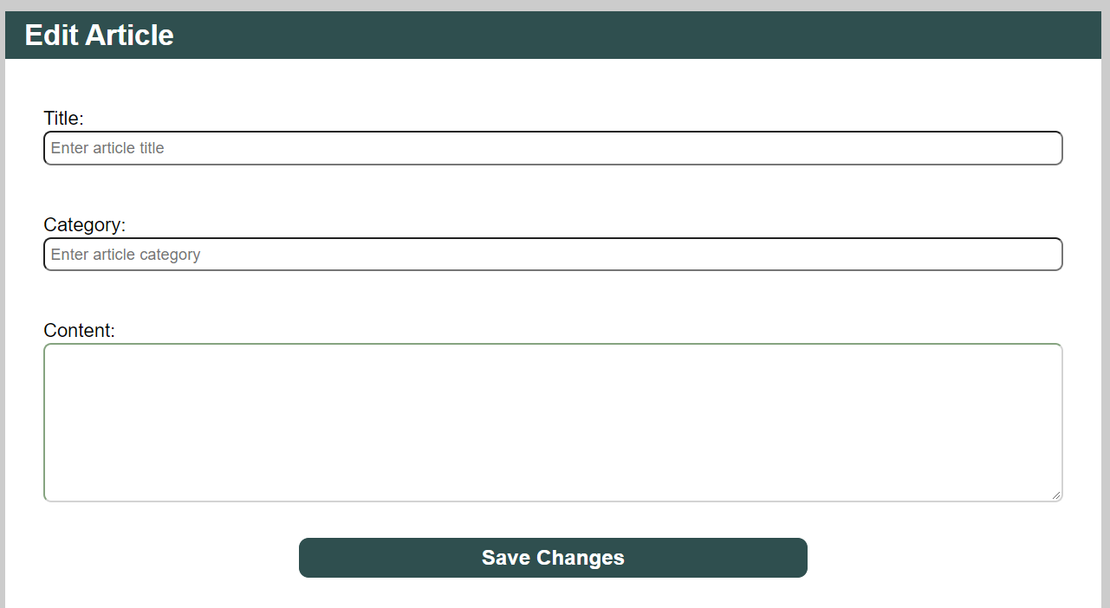

To edit an article, send the following **request**:

Method: PUT

URL: /data/wiki/*:id*

Where ***:id*** is the **id** of the desired article.

The service expects a body with the following shape:

{

title,

category,

content

}

Required **headers** are described in the documentation. The service will return the modified record. Note that **PUT** request **do not** merge properties and will instead **replace** the entire record. Upon success, **redirect** the user to the **Details** page.

### Delete Article (10 pts)

The delete action is available to logged-in users, for article they have created. When the author clicks on the Delete action on any of their articles, a confirmation dialog should be displayed, and upon confirming this dialog, the article should be deleted from the system.

To delete an article, send the following **request**:

Method: DELETE

URL: /data/wiki/*:id*

Where ***:id*** is the **id** of the desired article. Required **headers** are described in the documentation. The service will return an object, containing the deletion time. Upon success, **redirect** the user to the **Home** page.

### (BONUS) Search (5 pts)

The Search page allows users to filter articles by their title. It contains an input field and, upon submitting a query, a list of all matching articles.

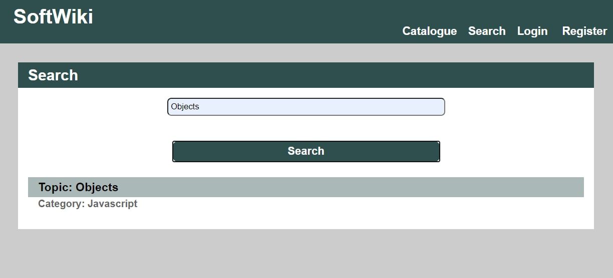

If there are no results the following message should be displayed:

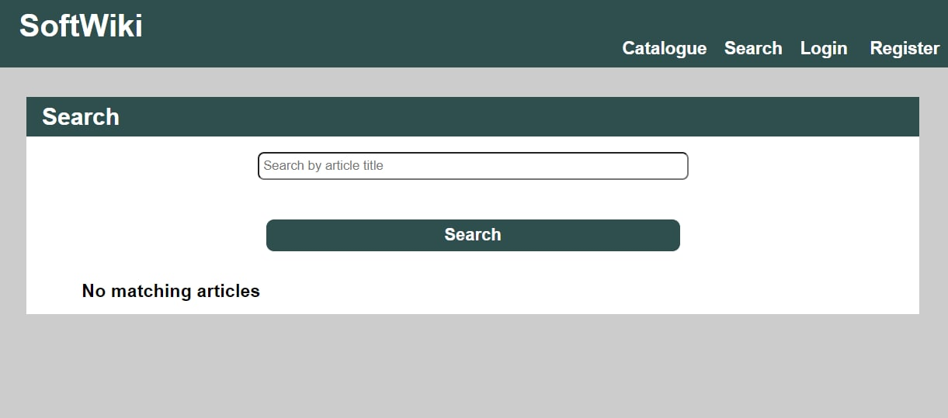

Send the following **request** to read a filtered list of articles by their title:

Method: GET

URL: /data/wiki?where=title%20LIKE%20%22*{query}*%22

Where ***{query}*** is the search query that the user has entered in the input field. Required **headers** are described in the documentation. The service will return an array of articles. If there are no matches, display the text **"No matching articles"** instead.